Creating Accessible Word Documents

Heading Styles
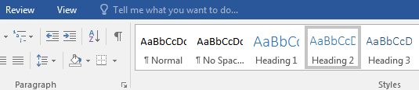

Create a uniform heading structure through use of styles in Word. This allows screen readers to navigate a document and improves accessibility for everyone.
- Start a new line to create a heading, or select text to change to a heading.
- Open the Home tab, and choose the appropriate heading in the Styles panel. Heading 1 is for the title of the document and the subsequent headers are 2, then 3, etc.
- Headings 1, 2, or 3 can also be assigned using Ctrl + Alt + 1, 2, or 3, respectively.

Adding Alternative Text
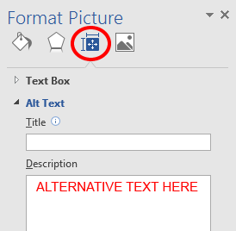
Images can be given appropriate alternative text in Word. Alt text is read by a screen reader in a Word file and should remain intact when exporting to HTML or PDF.
- Right-click on the image and select Format Picture. A dialog will appear.
- Click Edit Alt Text
- Enter appropriate Alt text only in the Description field (not the Title field). Keep it simple and brief.

Columns
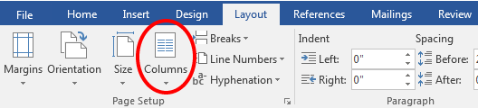
Always use true columns. Don’t create columns with Tab.
- Select the Layout tab on the ribbon.
- Select Columns in the Page Setup group.
- Choose the number of columns.

Lists
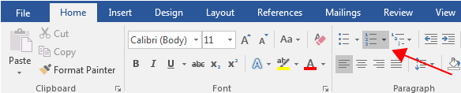

Use true numbered and bulleted lists to emphasize a point or a sequence of steps.
1. Select the Home tab on the ribbon.
2. Choose the Numbered List or Bulleted List option from the Paragraph group.

Hyperlinks
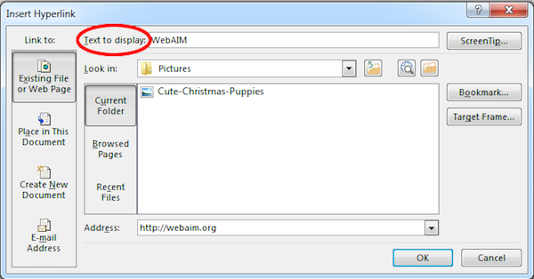
Word automatically creates a hyperlink when a user pastes a full URL onto a page. These may not make sense to screen reader users, so make sure the link text is unique.
- Select a hyperlink, right click, and select Hyperlink or hit Ctrl + k.
- Change the text in the Text to Display field to a more meaningful description.

Data Tables
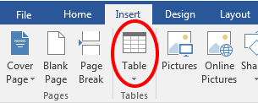
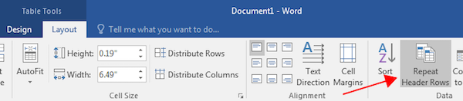
Accessible tables need a clear table structure and table headers to help guide a screen reader user.
- Select the Insert tab on the ribbon, then select Table > Insert Table.
- To add table headers to the first row, select Table Tools > Layout on the ribbon, then choose the Repeat Header Rows option in the Data section.
Options in the Design tab may be used to change appearance but will not provide the necessary accessibility information.

Add Title to the Document
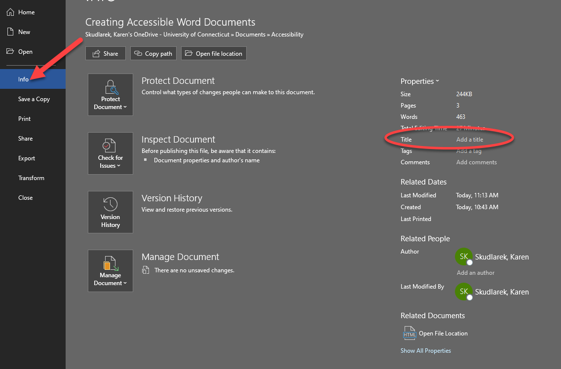

You need to set a default document title for a screen reader to be able to scan and read out loud to its user.
- Click File > Info
- Enter a title for the document

Accessibility Checker
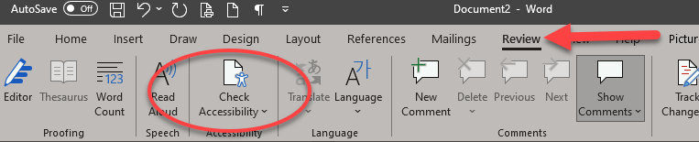
Word includes an accessibility resource that identifies accessibility issues.
- Click Review tab on the ribbon > Check Accessibility.
- The checker presents accessibility errors, warnings, and tips for making repairs.
Select specific issues to see Additional Information at the bottom of the task pane.

Other Principles
• Ensure that font size is sufficient, around 12 points.
• Provide sufficient contrast.
• Don’t use color as the only way to convey meaning.
• Provide a table of contents for long documents.
• Use simple language.

